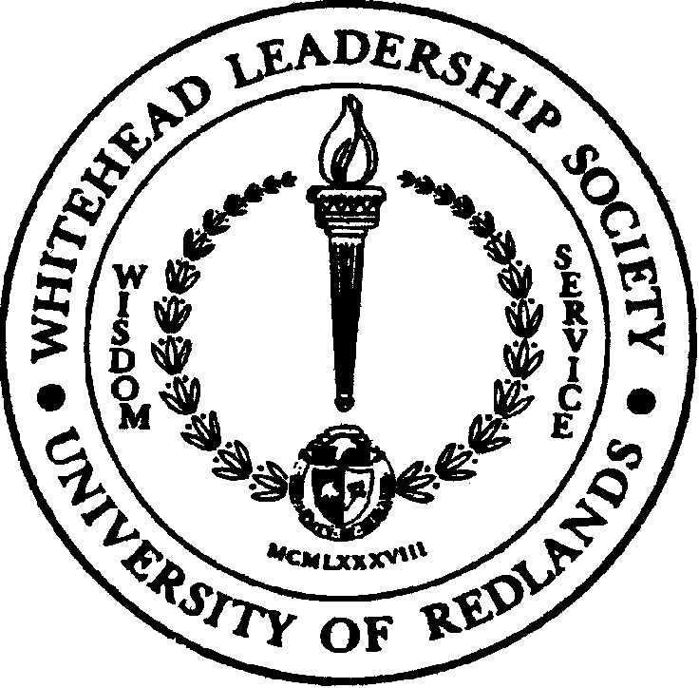
Whitehead Leadership Society

Scholarship for Purposeful Leadership

Spring 2023

Eligibility Guidelines and Application Form

“Purposeful leadership addresses the critical role leaders play in ensuring that organizations deliver value to customers in an effective, data-driven, meaningful, ethical, and socially responsible manner.”

– Thomas Horan, H. Jess and Donna Colton Senecal Endowed Dean, School of Business & Society

Scholarship Purpose
The Whitehead Leadership Society (WLS) Scholarship for Purposeful Leadership is inaugurated by the WLS Board of Directors to encourage purposeful leadership within the University of Redlands, School of Business & Society in keeping with the WLS traditions of socially responsible service and sustainable practices in the communities which our students work and live. At least one $500 scholarship award will be granted each fiscal year by the WLS.

Eligibility Requirements
The Whitehead Leadership Society (WLS) Scholarship for Purposeful Leadership is open to degree seeking School of Business & Society students (starting Fall 2022 semester and prior) in good standing with the University who have demonstrated outstanding purposeful leadership to the School of Business, to their professional occupation, and/or to the communities in which they work and live.

Interested students must complete and submit a Student Application Form, a résumé, and two letters of recommendation to be reviewed by the WLS Board of Directors. The scholarship winner(s) will be notified annually in the spring.

Scholarship Submission Requirements and Deadline
Part 1: WLS Scholarship Student Application Form (page 2)

Part 2: A current Résumé
Outlining your educational and professional background, experience, and accomplishments.

Part 3: Two Professional Letters of Recommendation
Students must obtain two written letters of recommendation from faculty, school administrator, work supervisor, colleague, and/or community member. Please ask individuals providing the recommendation to submit it electronically to you and to include the following:
- Reason(s) s/he believes you are a good candidate for the WLS Scholarship for Purposeful Leadership.
- Describe observations and experiences with you in the classroom, workplace, and/or community that demonstrate Purposeful Leadership.

Application packets are due to Charlotte Roth, Assistant Director of Student Engagement, at WLS@redlands.edu no later than 11:59 p.m. on Friday, February 3, 2023. All application requirements (all three parts) must be completed and submitted as one packet by the deadline for consideration.

All application packets will be reviewed for approval by the Whitehead Leadership Society Board of Directors.

Part 1: WLS Scholarship Student Application Form

Instructions: Applications are encouraged from students who best embody Purposeful Leadership by demonstrating leadership, service, and support at the University of Redlands, in your professional occupation, and/or within your community.

Your Name: Relationship to Student:

Student/Applicant’s Name and Contact Information

First Name: Last Name: Student ID#:
Cell Phone#: Degree Program:
Preferred Email Address: Expected Graduation Date:

Summary of reasons for application (50 words or more): Please state your reasons for applying and provide some examples of how you have demonstrated purposeful leadership to the University of Redlands, your professional occupation, and/or community.

